

GETTING TO NORTHWEST ARKANSAS
TRAVEL INFORMATION

The Northwest Arkansas Regional Airport (XNA) is serviced by the following airlines:

Allegiant Air www.allegiantair.com
American (Eagle) www.aa.com
Breeze Airways www.flybreeze.com
Frontier Airlines www.flyfrontier.com
Delta (ASA) www.delta.com
United Airlines www.united.com

Northwest Arkansas Regional Airport (XNA) is also referred to as “Fayetteville-Rogers-Bentonville Airport”. For further information, please see www.flyxna.com.
Link for airport info, driving distances, taxis and other travel info: http://www.experiencefayetteville.com/files/TransportationMap.pdf
Typical costs for private car, taxi or shuttle service to Fayetteville is from $40 - $75, depending upon number of travelers and type of vehicle. Just ask about pricing when you call. Most providers take credit cards as well as cash. Please inquire with your driver regarding methods of payment.
We highly recommend Jim’s Express Shuttle from the airport:
479-205-0011 or 866-535-0127

There are other airports to fly into that are likely to be cheaper, but they are more than 2 hours away and would require car rental. These are listed with the closest airports first.
Fort Smith Airport, Fort Smith, Arkansas (1 hour away)
http://fortsmithairport.com

Branson Airport, Branson, Missouri (2 hours away)
http://flybranson.com

Tulsa International Airport, Tulsa, Oklahoma (2 hours away)
http://www.tulsaairports.com

Bill and Hillary Clinton National Airport, Little Rock, Arkansas (4 hours away)
http://www.fly-lit.com

Lodging

Recommended Hotel Information
There are many reasonable chain hotels in the area, but if you are looking for something with more local flavor, here are four recommendations. They are similarly priced. Mt. Sequoyah is a two-minute drive or ten-minute walk from my house. Please reserve early as these popular inns and hotels fill up quickly.

The Graduate Hotel
70 N. East Ave.
Fayetteville, AR 72701
Toll free: 855-285-6162

Dickson Street Inn
301 W. Dickson Street
Fayetteville, AR 72701
479-695-2100

Inn at Carnall Hall
465 N. Arkansas Avenue
Fayetteville, AR 72701
479-582-0400
innatcarnallhall.com

Mt. Sequoyah
150 N. Skyline Drive
Fayetteville, AR 72701
479-443-4531

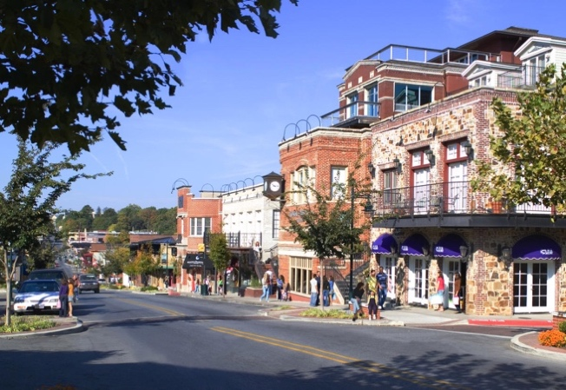
Other Options:

Courtyard by Marriott
Airbnb Fayetteville, AR
VRBO Fayetteville, AR
(VRBO has more listings)
WHAT TO DO IN FAYETTEVILLE

Fayetteville Visitors Guide
https://www.experiencefayetteville.com/guide
Fayetteville Chamber of Commerce:
http://www.fayettevillear.com
Experience Fayetteville:
http://www.experiencefayetteville.com
University of Arkansas – Fayetteville
http://Uark.edu
Video Tour of Fayetteville:
http://www.elocallink.tv/clients3/ar/fayetteville2013/tourplay.php?movie=fayar13_wel_rev1_iwd&spon=welcome
There are lots of good restaurants of all types in Fayetteville. You can find everything from inexpensive and tasty barbecue, to delicious farm-to-table, and high-end gourmet restaurants, along with a wide selection of ethnic cuisines. A list of recommended restaurants will be provided at the retreat.
OTHER SIGHTS IN NORTHWEST ARKANSAS

Beaver Lake – local recreation area,
http://www.arkansas.com/outdoors/water-activities/lakes-rivers/lake.aspx?id=1
Buffalo River – the only National River in the country – over 135 miles of protected river
http://www.nps.gov/buff/index.htm
Crystal Bridges Museum – the largest museum of American art in the world
http://crystalbridges.org
Walmart Museum – visit the first store created by Sam Walton on the square in Bentonville, AR
http://walmartmuseum.com

Judi Neal Contact Information
+1 479-871-9116
745 N. Sequoyah Drive
Fayetteville, AR 72701
judi@edgewalkers.org

